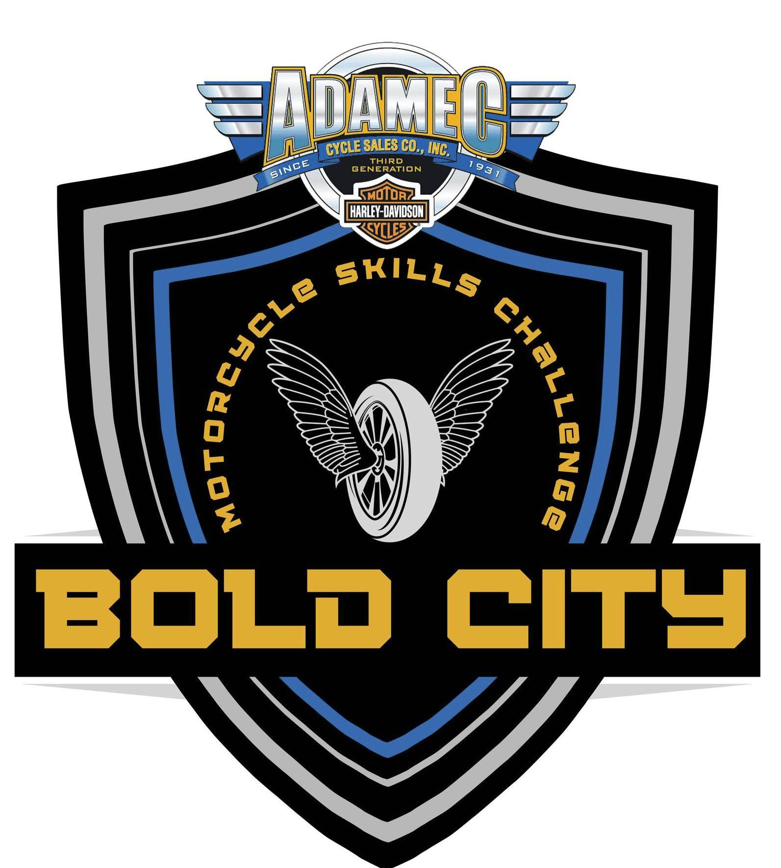
RIDER ENTRY FORM
BOLD CITY POLICE
MOTORCYCLE SKILLS CHALLENGE
FEBRUARY 11 - 14, 2026
JACKSONVILLE, FL

AGENCY: ______________________________________________________
CONTACT: ______________________________________________________
ADDRESS: ______________________________________________________
CITY: _____________________ STATE: ______ ZIP CODE: ________
PHONE: _____________________ FAX: ___________________________
EMAIL: ______________________________________________________

NAME | AGE | DIVISION | NOVICE (YES/NO)

PLEASE MAKE ALL CHECKS PAYABLE TO: LEGACY FOUNDATION
ONLINE REGISTRATION CAN BE COMPLETED BY VISITING WWW.BOLDCITYPOLICEJAX.COM
Mail checks to: Legacy Foundation (Credit Cards Accepted - Call (904) 338-1865)
Individual Rider Entry Fee of $125.00. PLEASE PAY IN ADVANCE
___________ # of Individual Riders X $125.00 each = ___________
___________ # of Individual Banquet Tickets X $50.00 each = ___________
(Competitor Banquet and Award Ticket is complimentary, each guest is $50)
BANQUET TO BE HELD ON FEBRUARY 14, 2026 (Adamec Harley Davidson - Baymeadows)
PLEASE INCLUDE YOUR BANQUET TICKET MONEY ($50.00 per guest) WITH THIS ENTRY FORM

